**Installing MetaMask on Firefox**

Step 1: Search for MetaMask and click on Download and then click “Add”

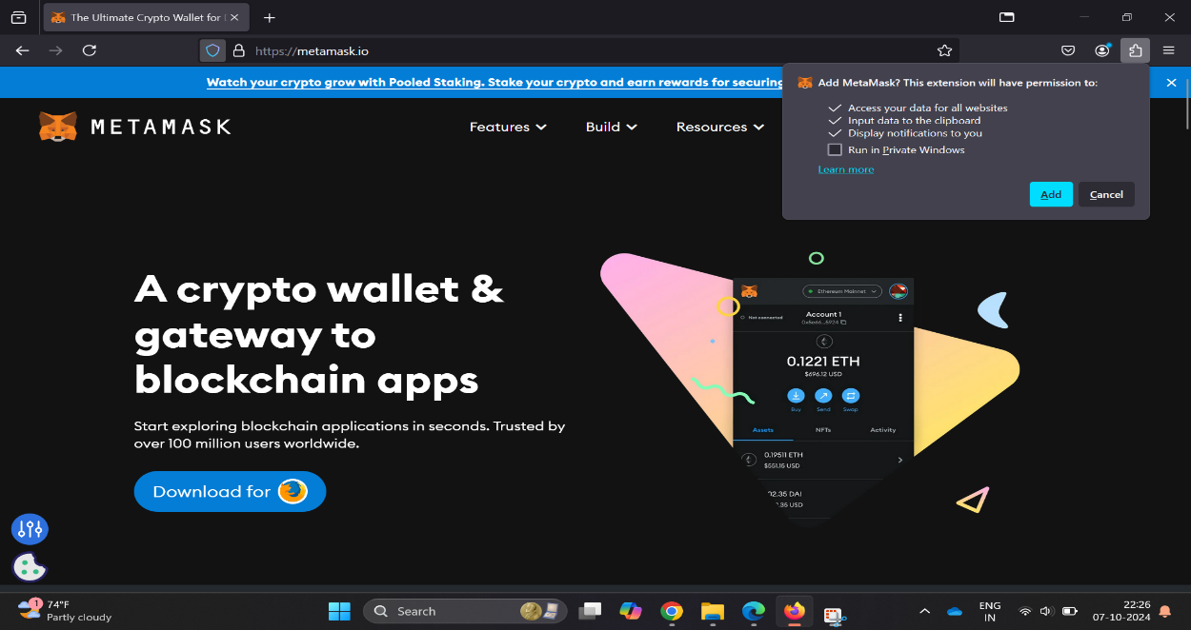

Step 2: Click on create new wallet

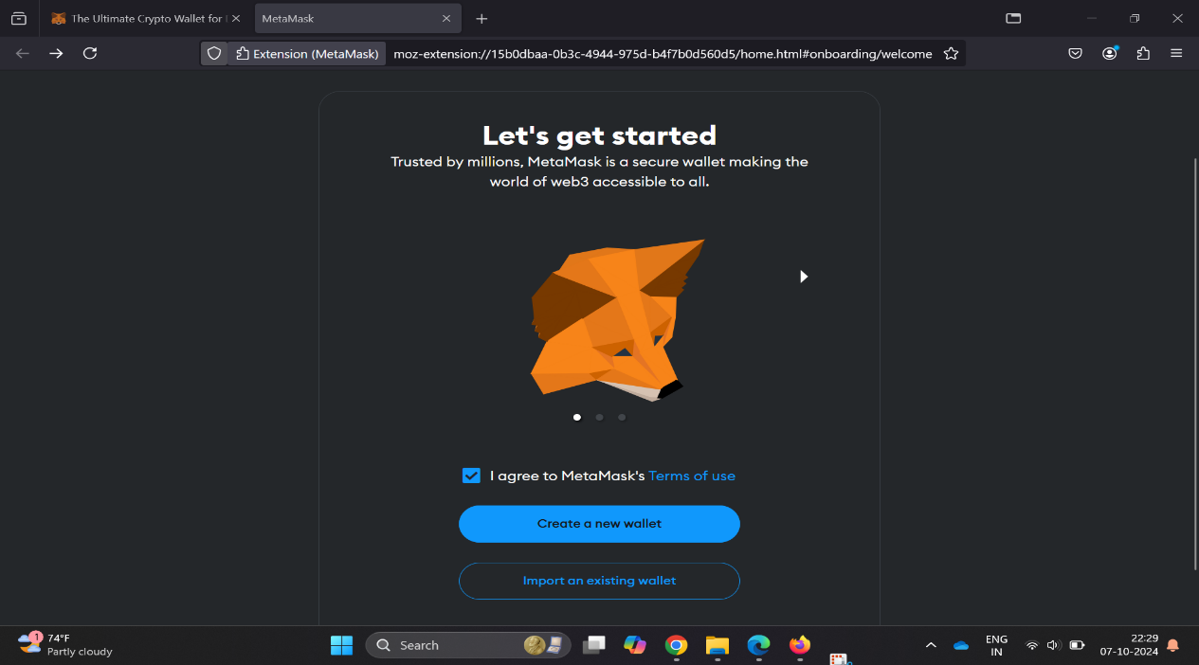

Step 3: Click on “I agree”

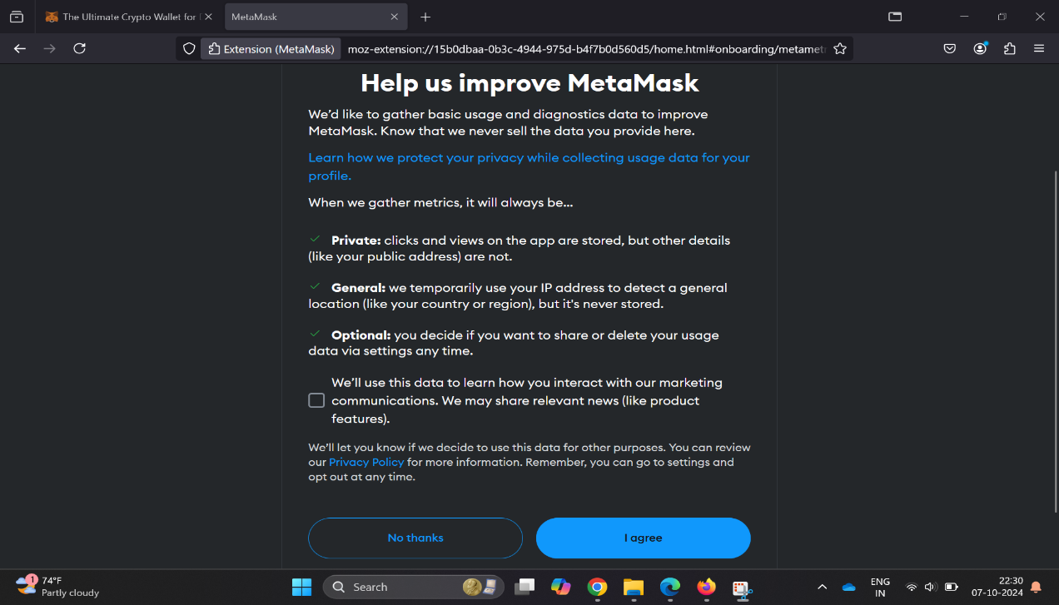

Step 4: Add strong password

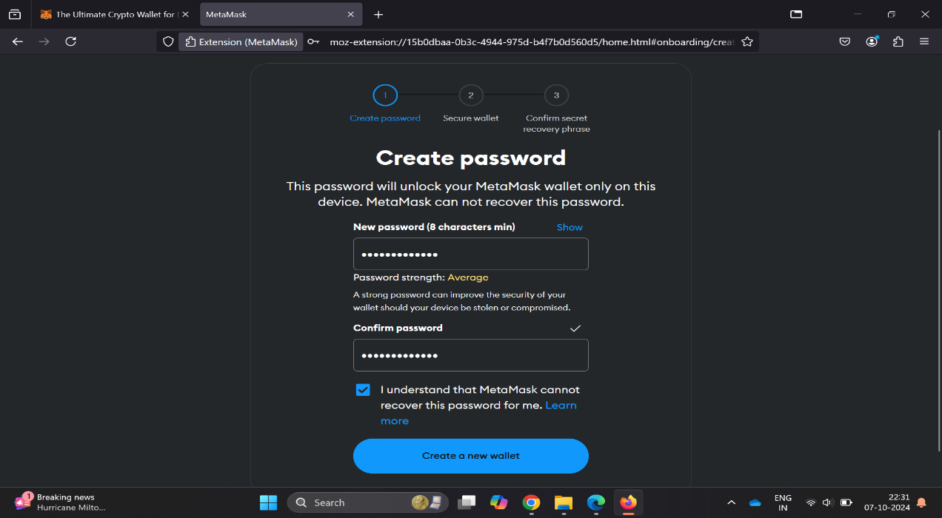

Step 5: Click on “Secure my wallet”

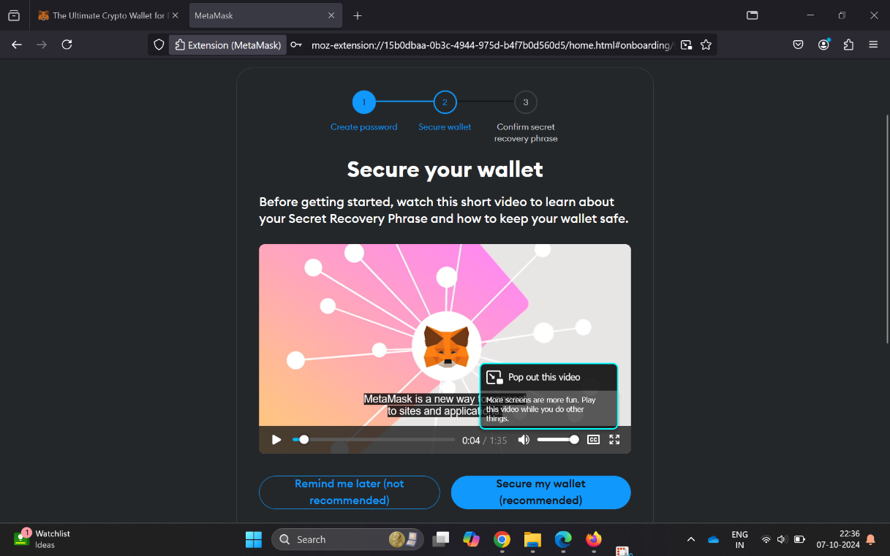

Step 6: Click on “Reveal Secret Recovery Phase”

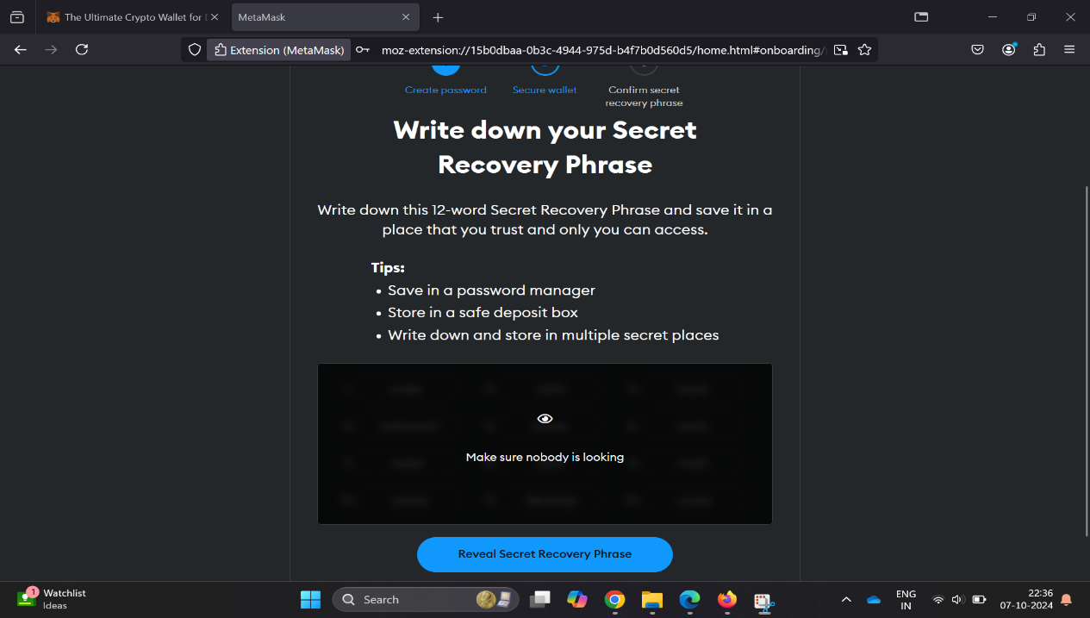

Step 7: Click on “Got it”

